

Western Cape Collaborator Portal
Combined Step-by-Step User Guide
Covering:
1. Creating a Collaborator Account
2. Activating Account Services (Register a Practice / User)
3. Registering a New Events Application on the Portal
Prepared for internal reference — Business Engineering / Collaborator Software

Table of Contents
1. Creating a Collaborator Account 3
2. Activating Account Services (Register a Practice / User) 7
3. Registering a New Events Application on the Portal 9

1. Creating a Collaborator Account
Every user must first create a Collaborator account before any municipal service can be activated.
The Collaborator Portal allows you to interact electronically with various municipalities to perform a selection of services. Before you can use the Portal you must first create your Collaborator account — a records-management and business-system login that gives you access to the Portal.
Step 1. Open the Collaborator sign-in page
Go to the Collaborator sign-in page:
https://westerncape.collaboratoronline.com/default.aspx
On the sign-in page, click Create Account.
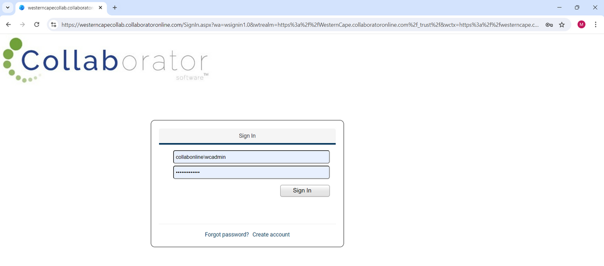
Step 2. Complete your details
Fill in all the required fields (First Name, Surname, Cell, Email, Password, Confirm Password and the security code shown) and click Submit.
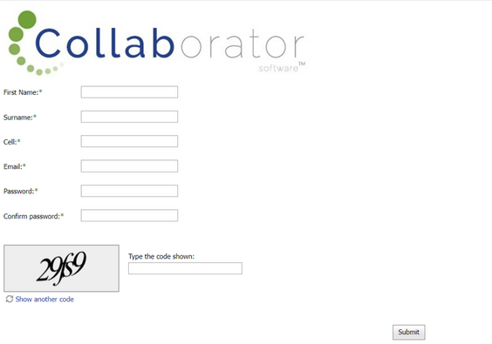
Step 3. Go to the Portal homepage
You will be redirected to the Western Cape Collaborator Portal homepage. Click on the Account option on the top menu bar.
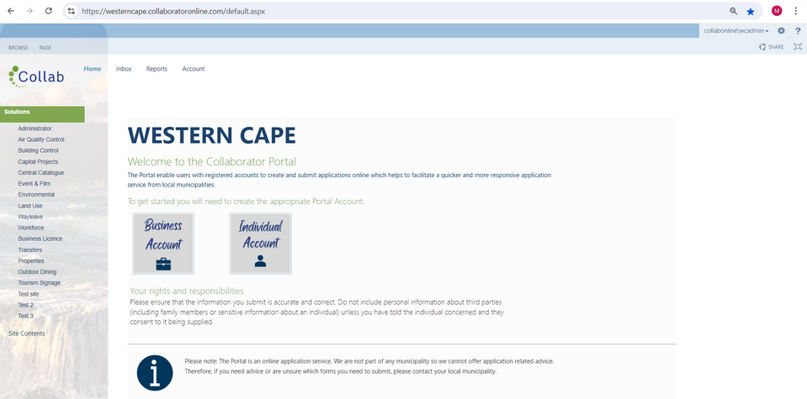
Step 4. Register a Partner
Click on the action button (…) next to your name and select Register Partner.
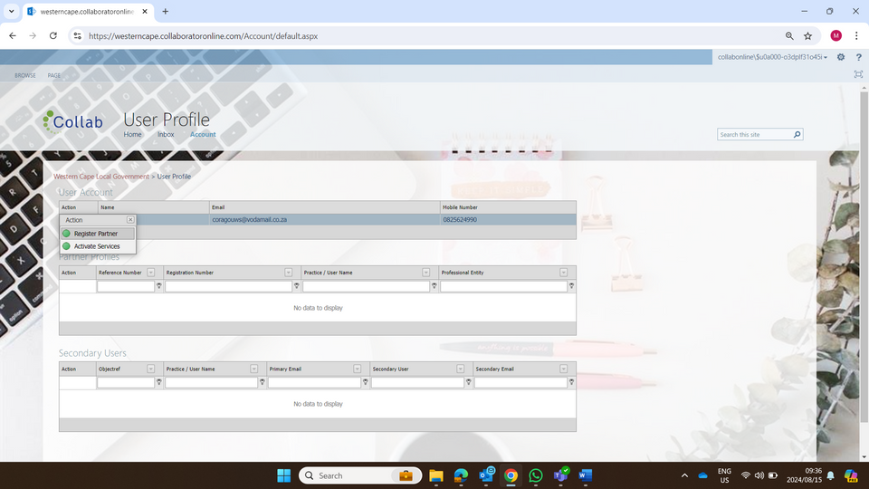
Step 5. Complete the Partner registration tabs
Complete all the fields across Step 1, Step 2 and Step 3 of the Create Account and Activate Services task before clicking Submit.
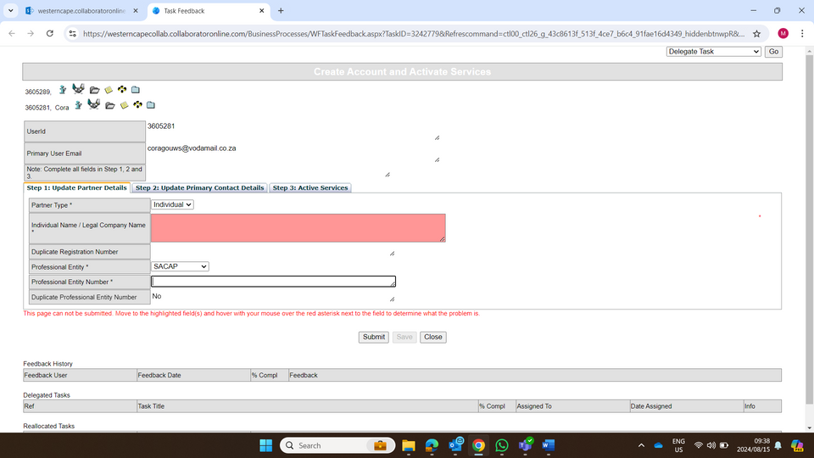
Step 6. Confirm your Partner Profile
Once all three tabs have been completed and you click Submit, you will be taken back to the User Profile screen where your details will display under Partner Profiles.
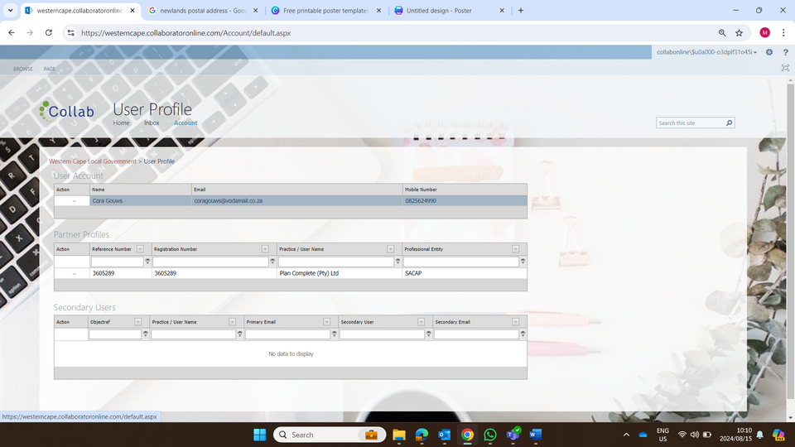
Step 7. Return to the home screen
Return to the home screen and select the application you want to use, e.g. Building Control, Environmental (OSCAE), Event & Film, etc.
Step 8. Complete the application-specific tabs
Complete all information under each of the relevant tabs (for example, for Building Control: Location / Owner / Application / Checklist / Architectural Practitioner / Invoicing).
Note: Wherever a field has an action button (…), use it to select from the provided list. If you type the information in directly instead of using the action button, you will NOT be given the Submit option once you reach the last tab.

2. Activating Account Services (Register a Practice / User)
Register a Practice or User profile so that you can activate additional municipal services.
Once you have logged in, you will be required to register your Practice on the site. On the Portal's landing page you will see the Home, Inbox and Account tabs.
Step 1. Open the Account tab
From the landing page of the Portal, navigate to the Account tab. The User Account web part will display the name and email address that was used to create your login.
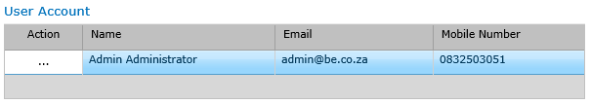
Step 2. Register your Practice
Select the action button (…) next to your name and choose Register Practice/User (Building Control) from the dropdown list.
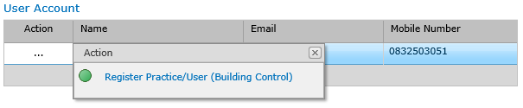
Step 3. Capture your Practice information
A Capture Practice Information task will open. All required fields must be completed before the task can be submitted:
- Select Applicant Type — Owner or Practice.
- If Practice is selected, enter your company's Registration Number.
- Complete the remaining contact fields, then select Submit.
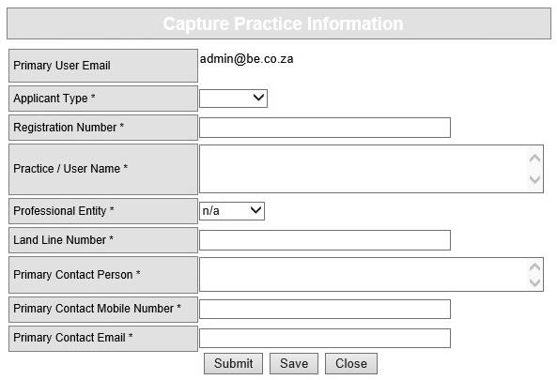
Step 4. Confirm on the relevant service page
Go back to the Home page, select the relevant service (e.g. Building Control), then select the application type (e.g. Building Plan Application). The Practice you created will appear in the Practice/User web part.
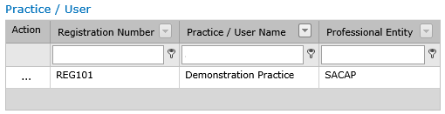

3. Registering a New Events Application on the Portal
Loading a New Events Application on the Portal
This section walks through submitting a new Event application, from logging in through to final submission to the Municipality, including uploading all required supporting documents.
Step 1. Log into the Portal
Go to the site https://westerncape.collaboratoronline.com
Type in your Username and Password in the fields provided.
Should you not have an account, click on Create an Account.
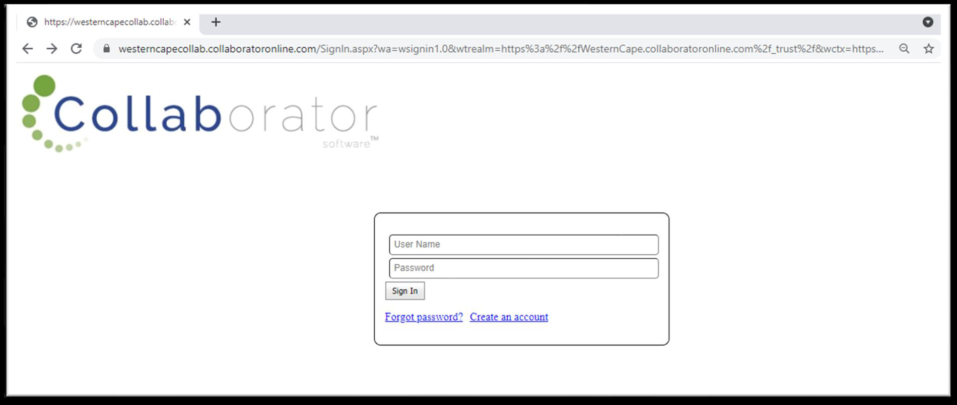
Step 2. Portal — Landing Page
Once logged in, you will see the Portal landing page.
On the left-hand side, look for Event & Film.
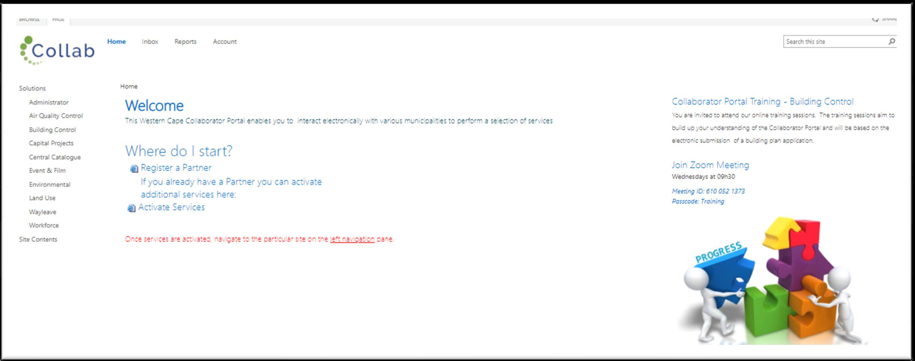
Step 3. Event & Film — Landing Page
When you are on the Event & Film landing page, select Events Management on the left-hand side.
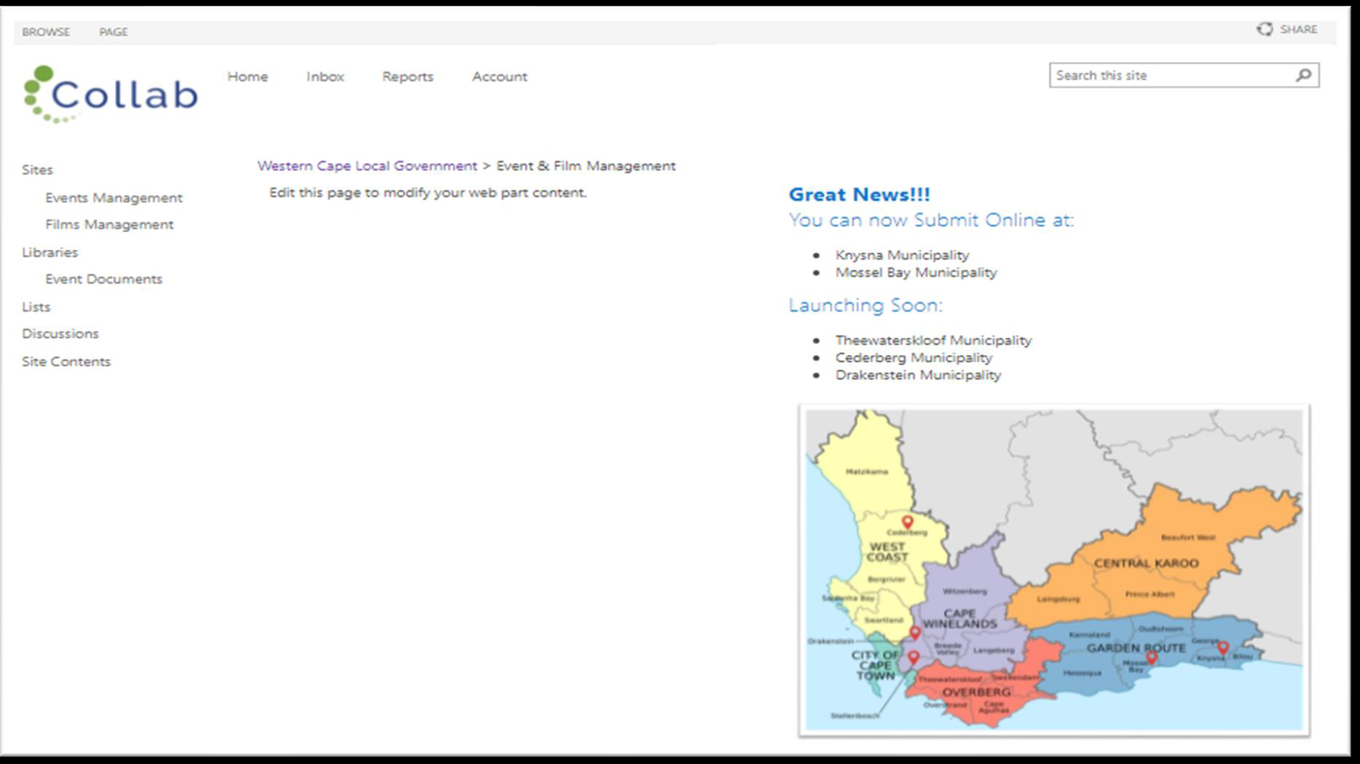
Step 4. Event Management — Landing Page
The Event Management landing page displays the Partner web part, which shows your partner account.
Select New Event Application on the right-hand side to begin.
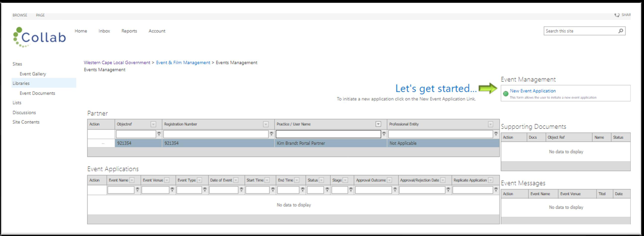
Step 5. Select the Municipal Area
When you open the task, you will see the fields in the top section of the form.
In the Municipal Area field, click the action button.
A data source will open — select your municipal area and click Submit.
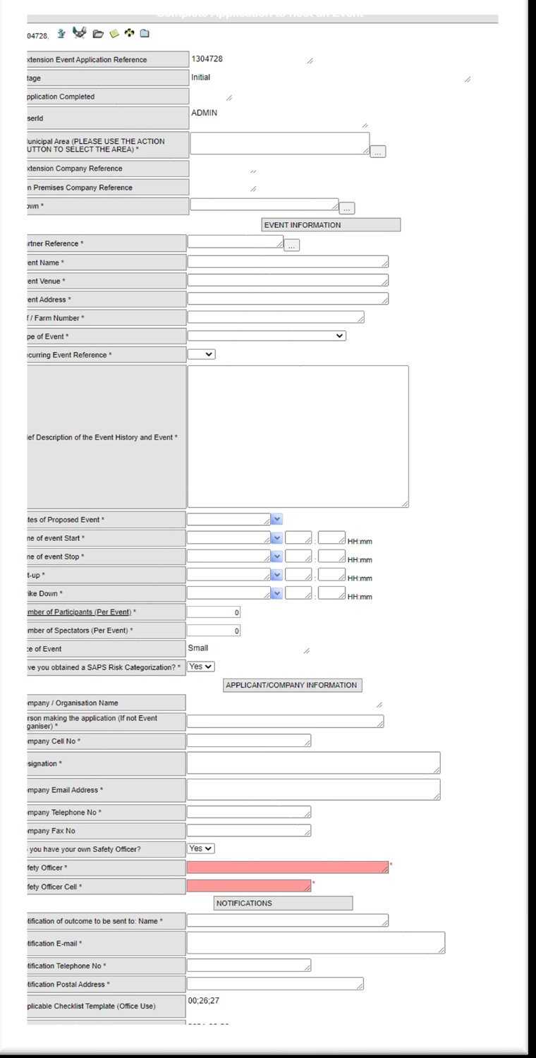
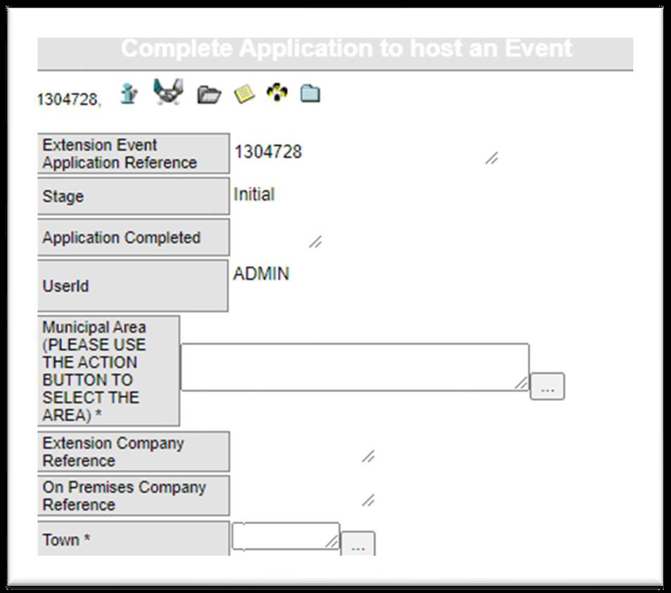
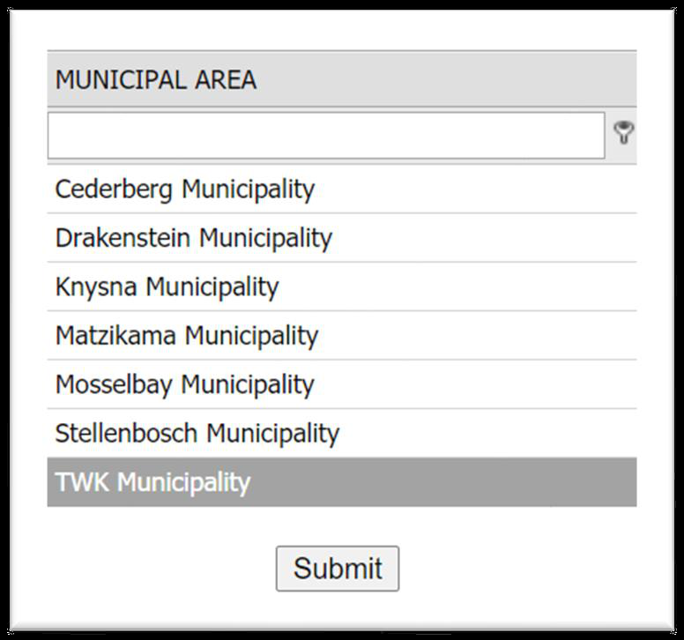
Step 6. Select the Town
In the Town field, click the action button.
A data source will open — select your town and click Submit.
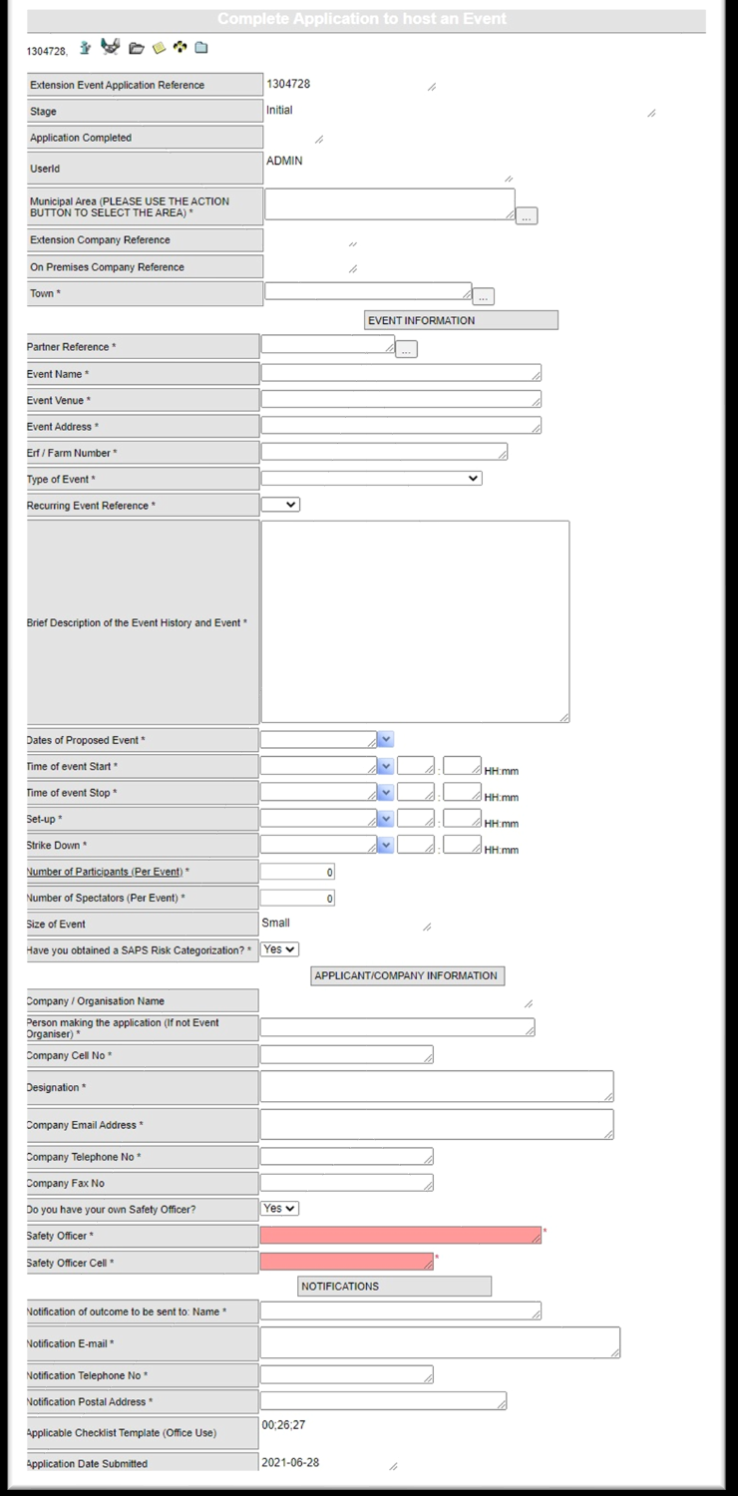
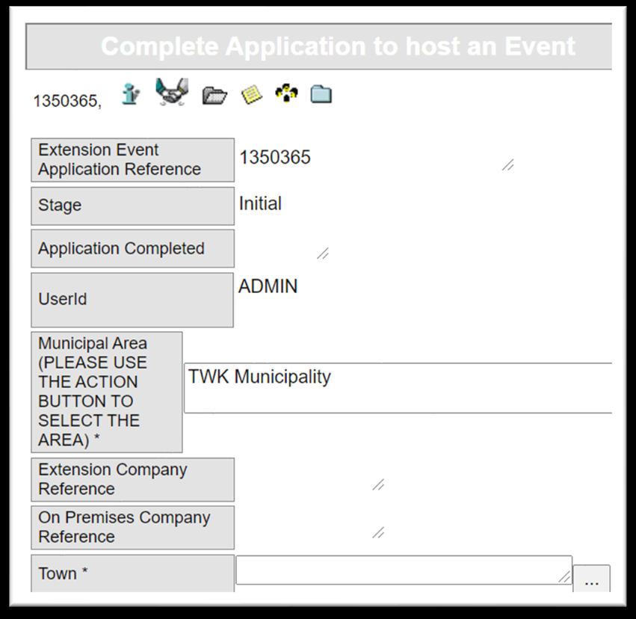
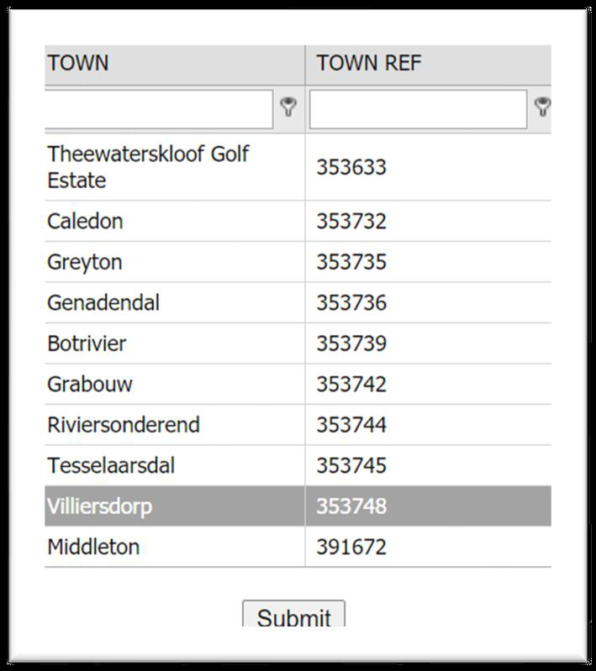
Step 7. Select the Partner Reference
In the Event Information section, click the action button on the Partner Reference field.
Select your Partner account, then click Submit.
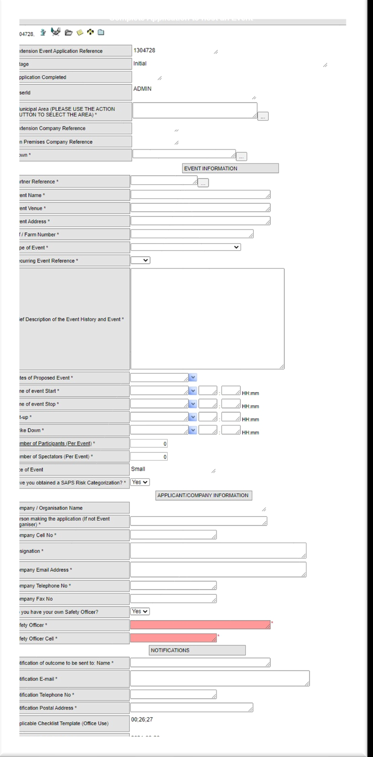
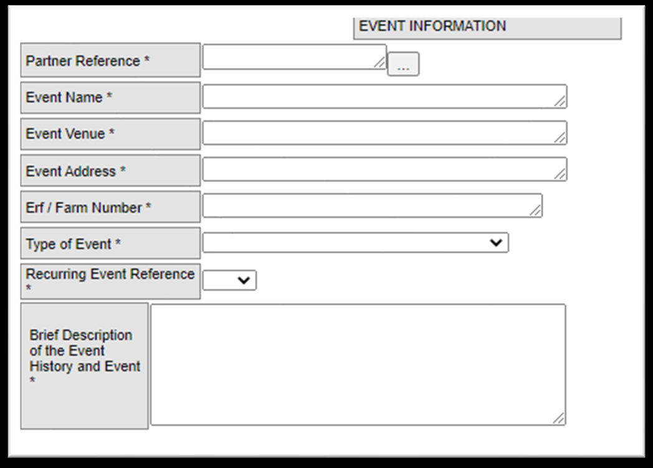
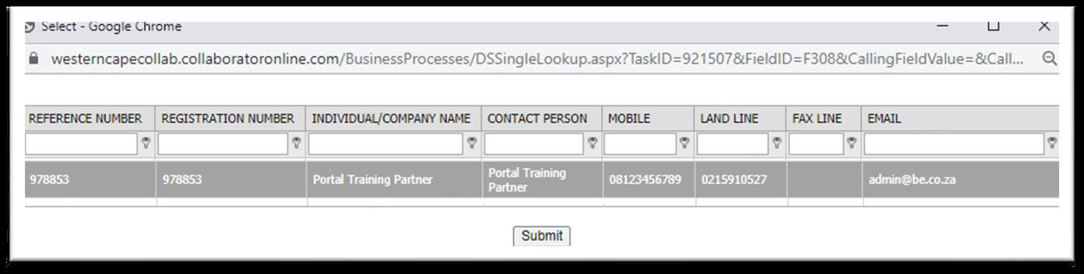
Step 8. Complete the Event details and Type of Event
Complete the text fields relating to the event: Event Name, Event Venue, Event Address, Erf/Farm Number.
On Type of Event, select the appropriate option from the list (Sport/Action, Concert/Music Festival, Charity Fundraise/Run/Walk, Political, Fete/School Carnival, Weddings/Birthdays, Market, and others).
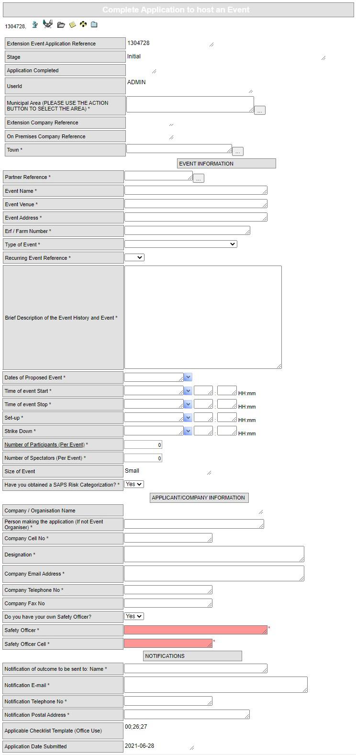
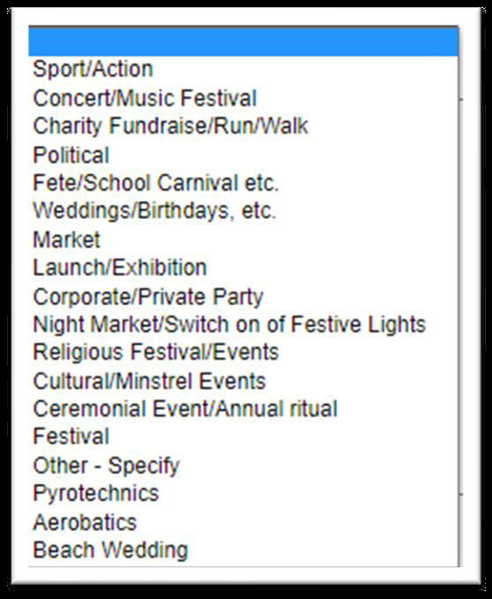
Step 9. Recurring Event Reference and description
Select Yes or No for Recurring Event Reference.
Add a description of the event in the text field provided.
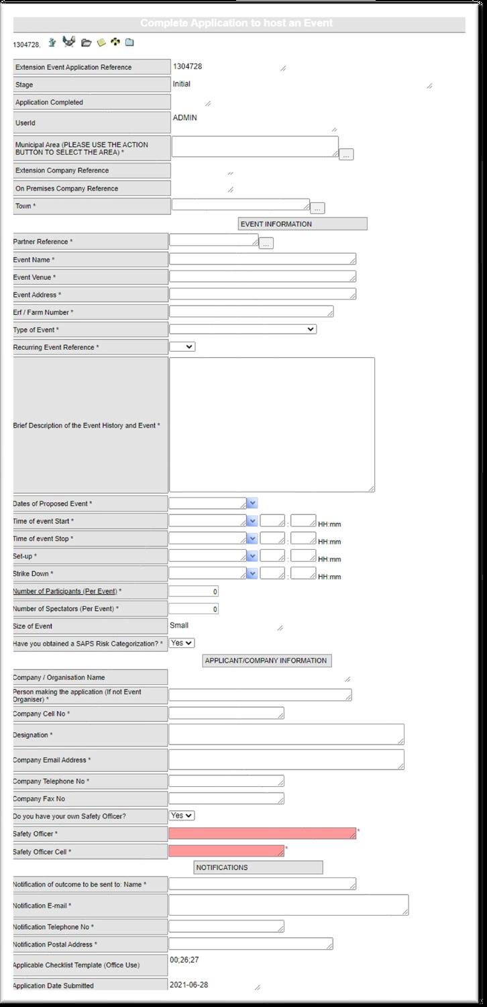
Step 10. Event dates, attendance and risk categorisation
Complete all date fields related to the event, along with the number of participants and spectators.
Select Yes if you have already obtained your SAPS Risk Categorisation.
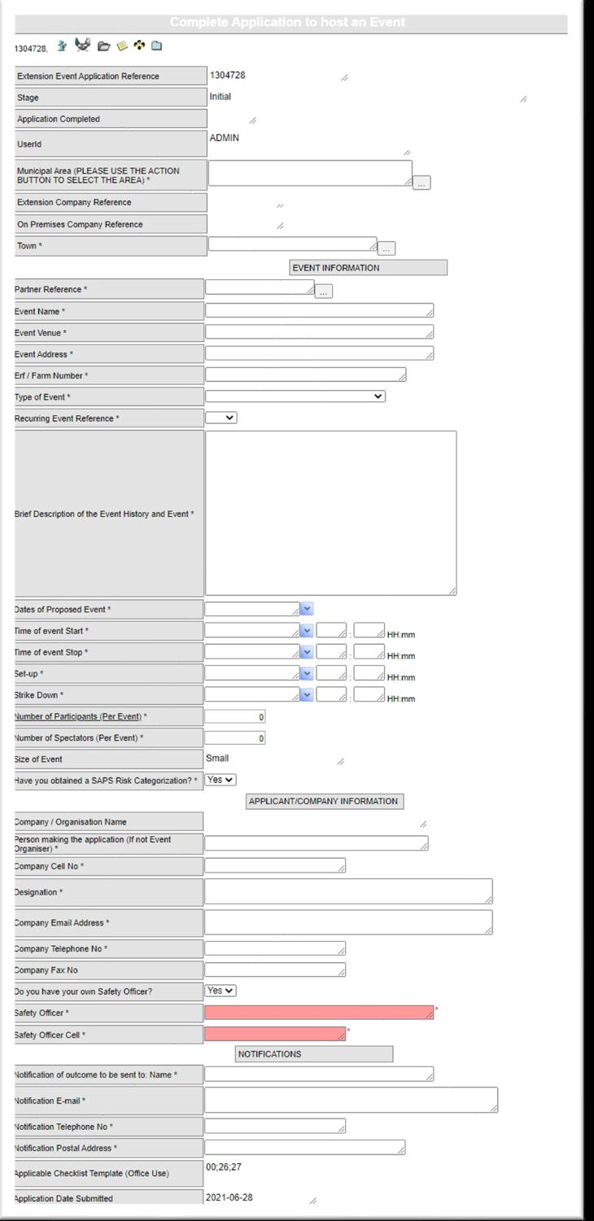
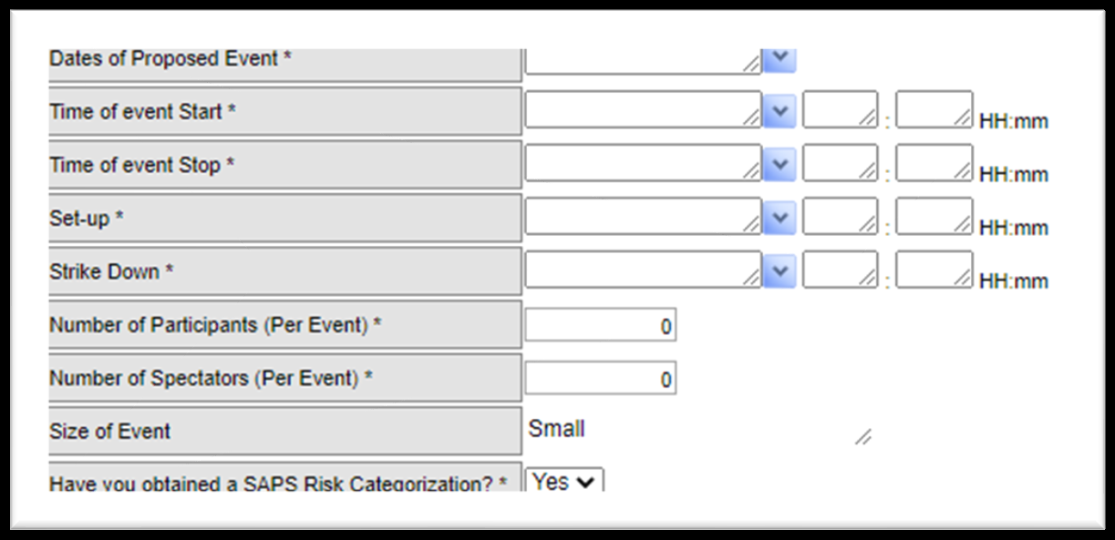
Step 11. Applicant / Company information
The next fields contain the details of your partner account; this information can be changed if necessary.
Select Yes if you have your own Safety Officer, then provide their contact details — otherwise leave these fields blank.
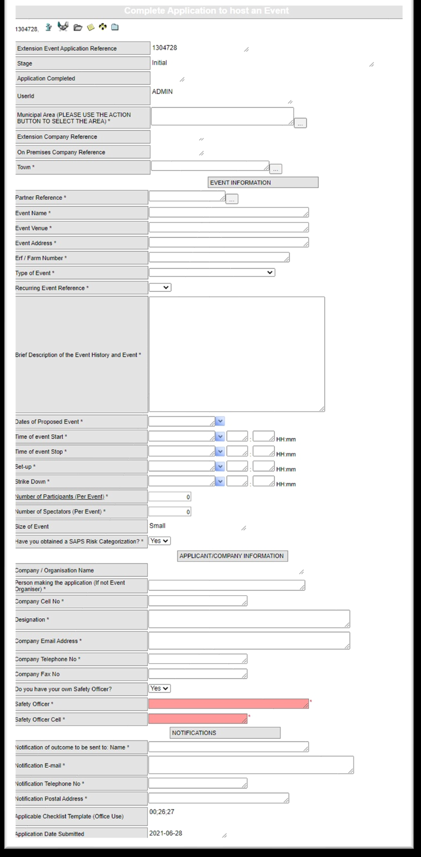
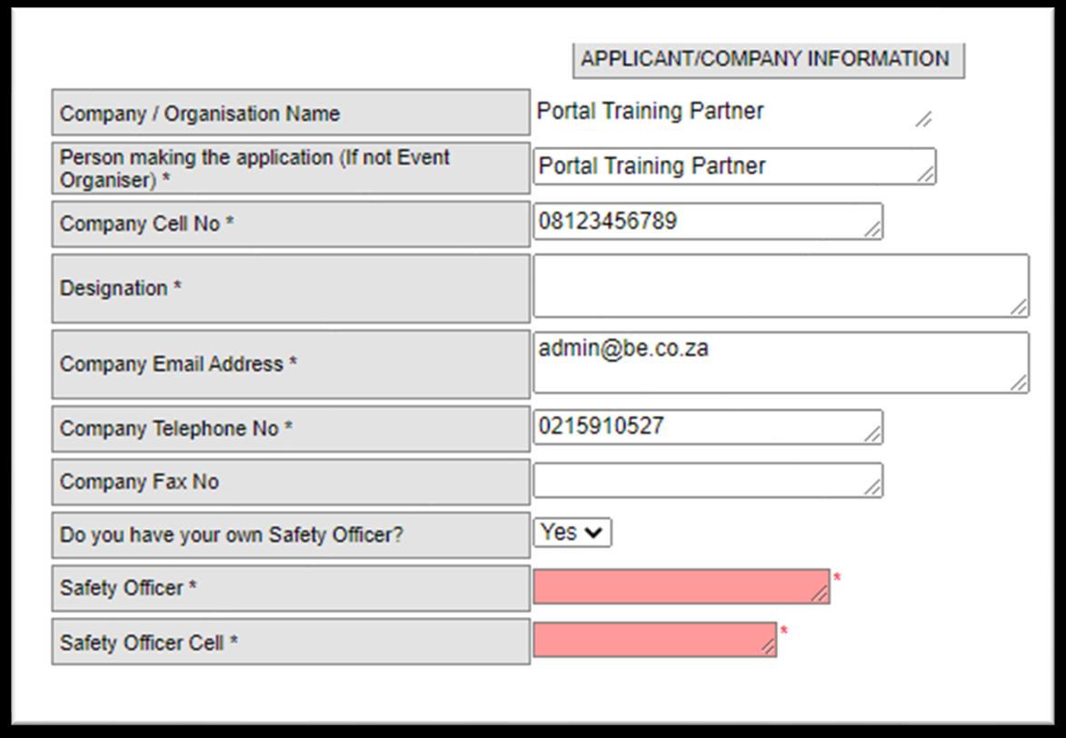
Step 12. Notifications
The contact details from your Partner Account are shown by default and can be changed per application if needed.
The email address entered here is where ALL notifications for this specific application will be sent.
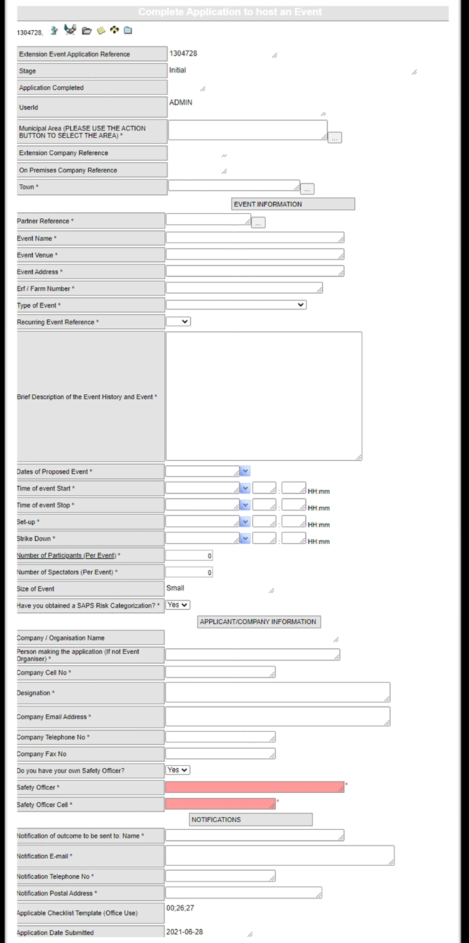
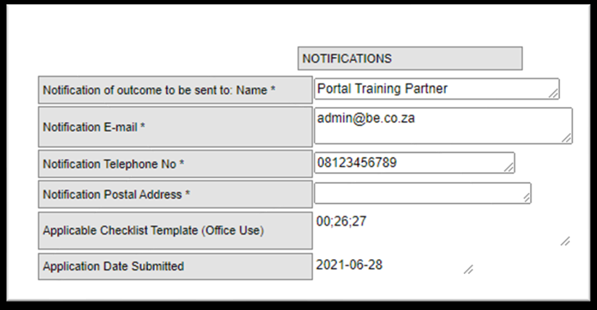
Step 13. Traffic tab
Complete the fields relevant to the event.
Make sure there are no red (mandatory, incomplete) fields remaining on screen.
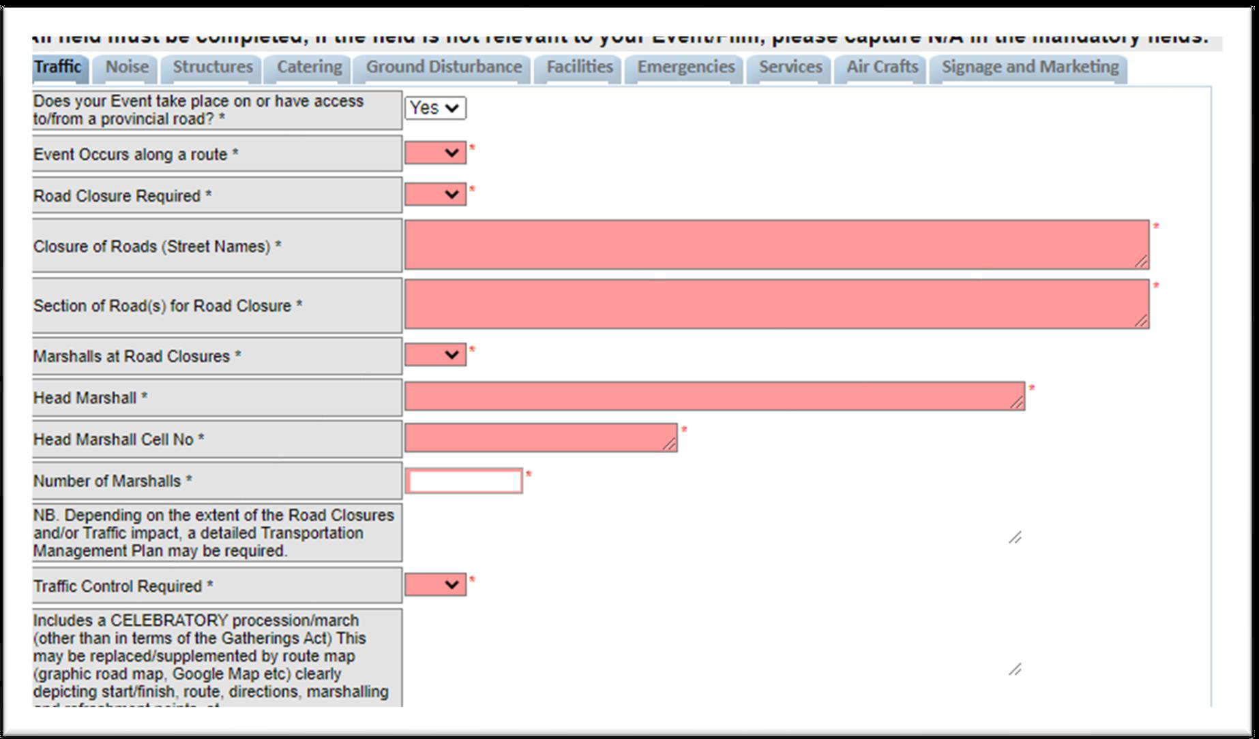
Step 14. Noise tab
Complete the fields relevant to the event and make sure there are no red fields remaining.
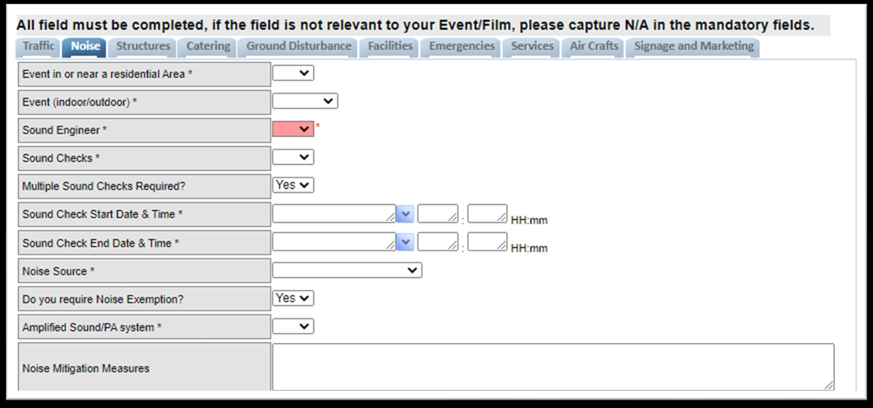
Step 15. Structures tab
Complete the fields relevant to the event, selecting options from the dropdown lists and completing all date and text fields.
Make sure there are no red fields remaining on screen.
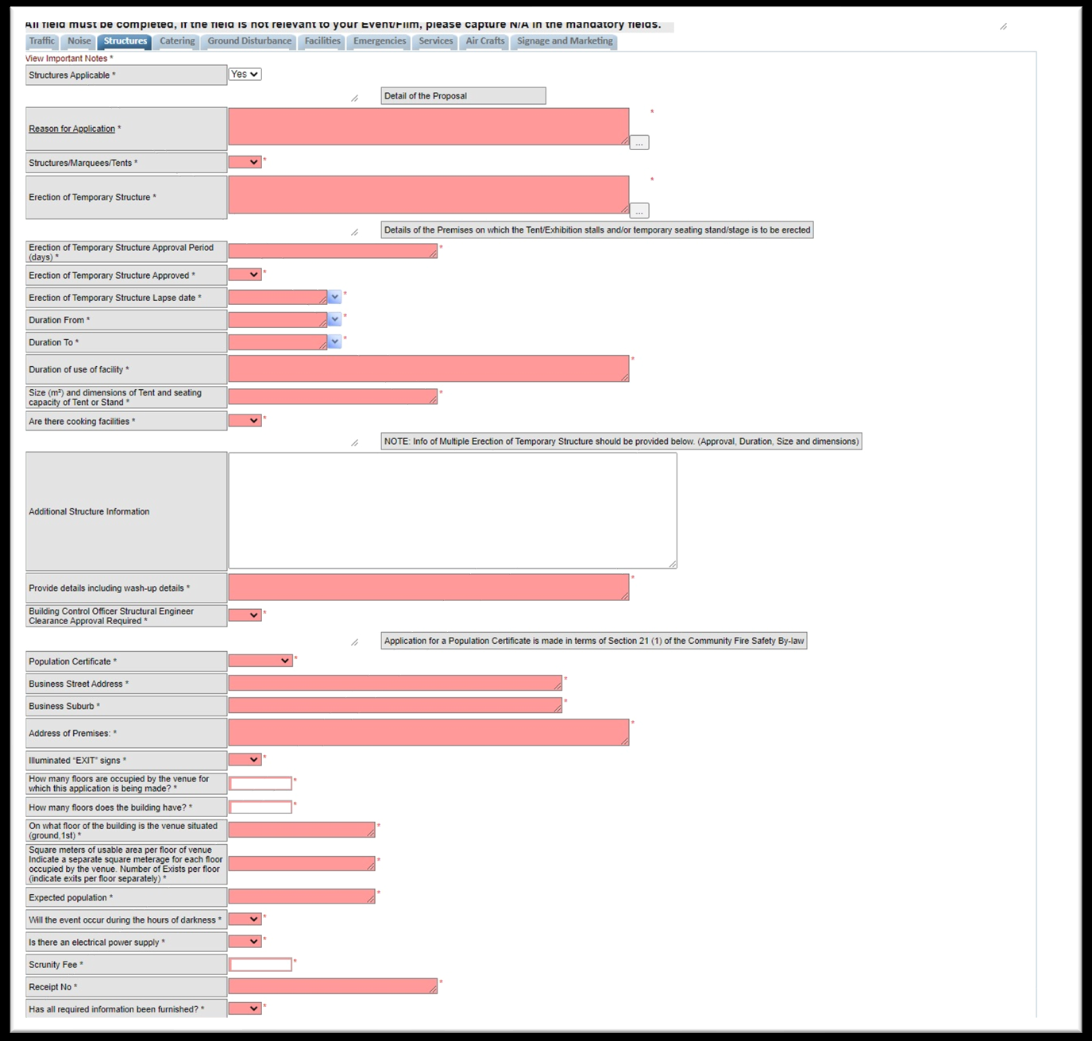
Step 16. Catering tab
Complete the fields relevant to the event, selecting options from the dropdown lists and completing all date and text fields.
Make sure there are no red fields remaining on screen.
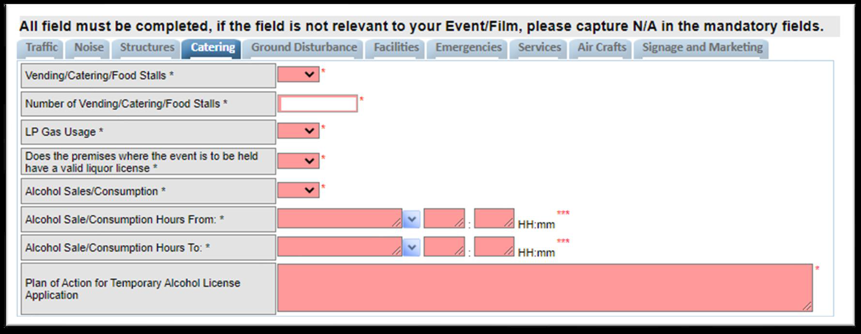
Step 17. Ground Disturbance tab
Select Yes or No, and complete the text field if necessary.
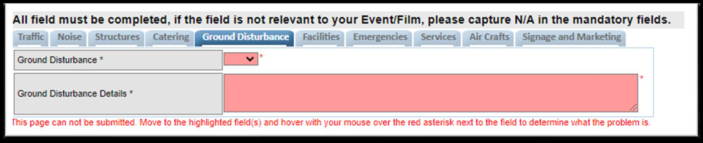
Step 18. Facilities tab
Fill in the number of existing toilets the venue has.
If additional facilities are needed, select Yes.
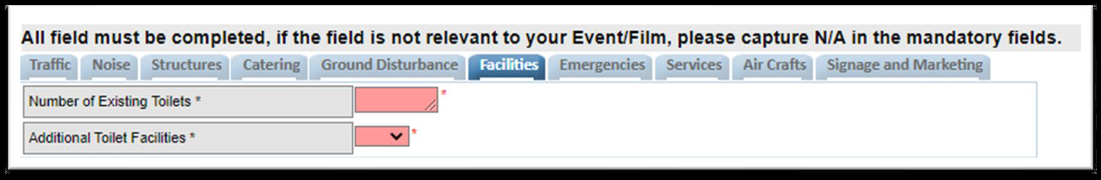
Step 19. Emergencies tab
Complete all the necessary fields and text fields.
Make sure there are no red fields remaining on screen.
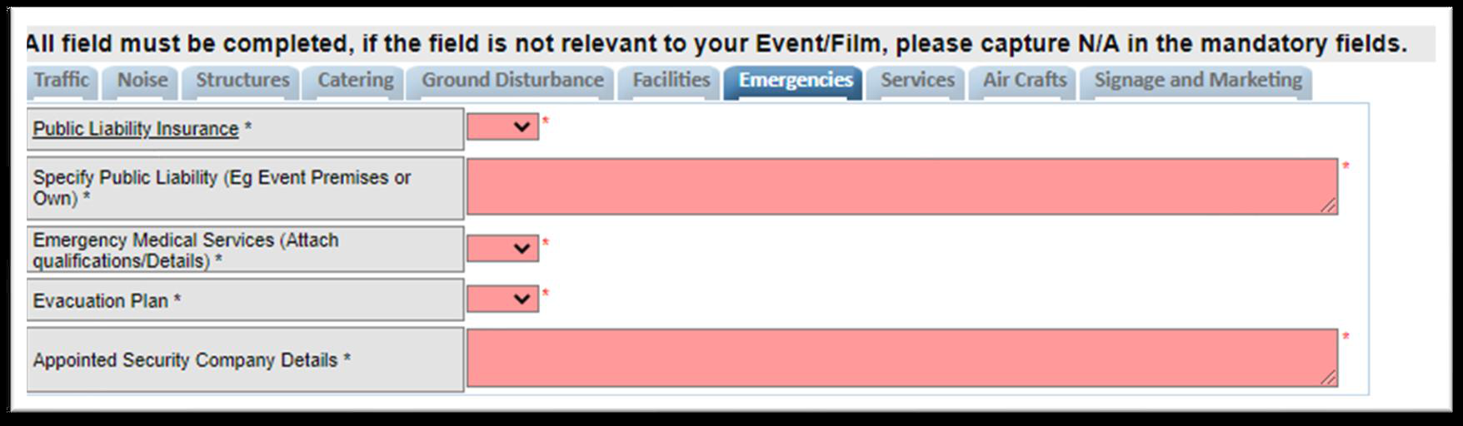
Step 20. Services tab
Complete all the fields relevant to the municipal services required for the event.
Make sure there are no red fields remaining on screen.
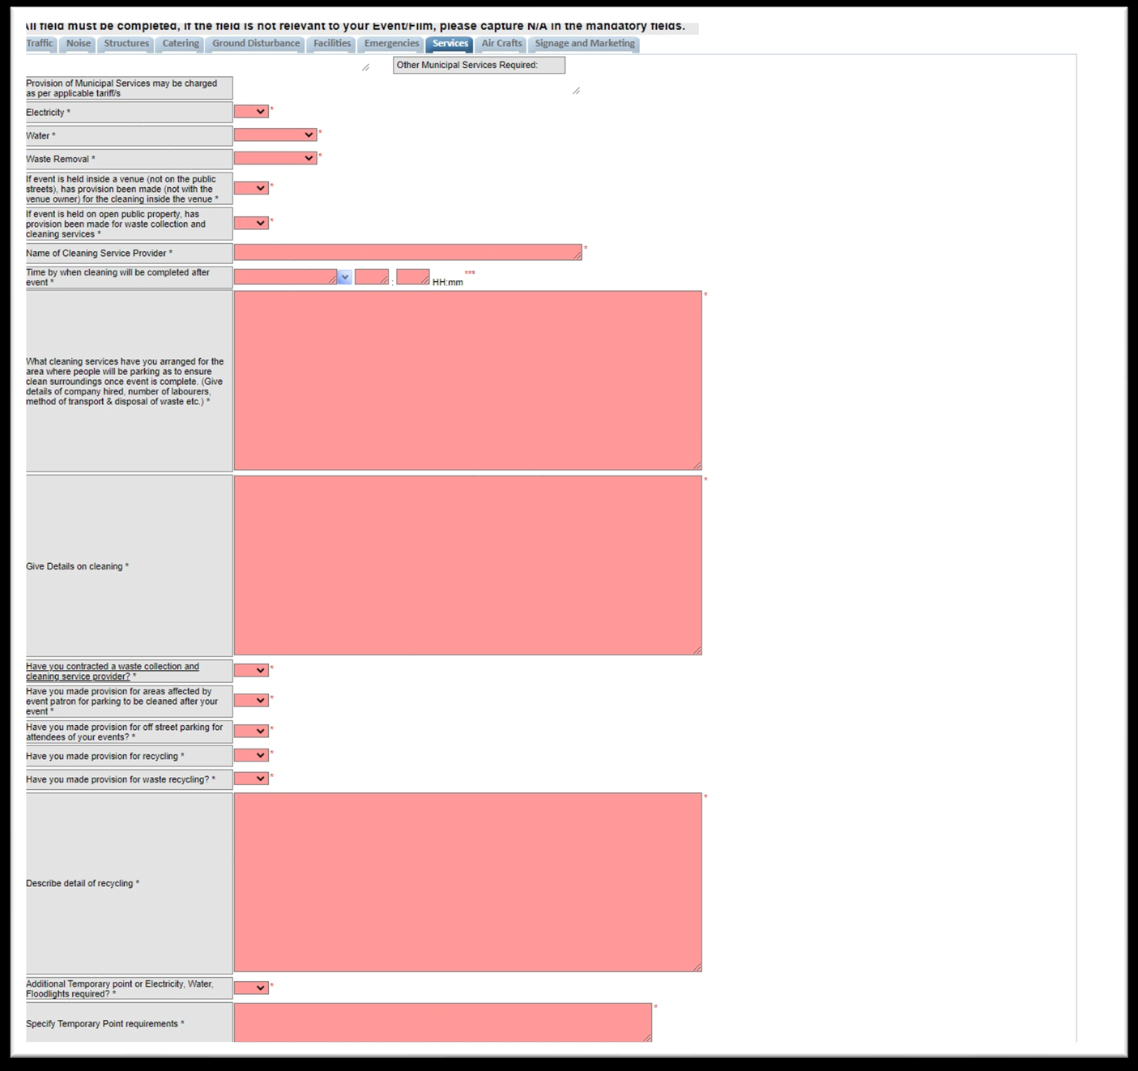
Step 21. Air Crafts tab
Select Yes or No depending on whether aircraft are required for the event.
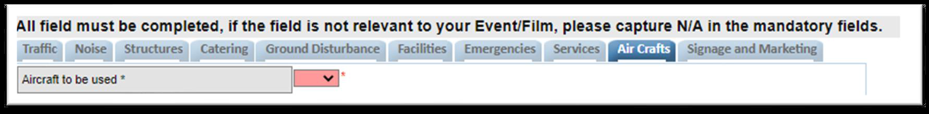
Step 22. Signage and Marketing tab
Complete all the necessary fields and text fields, and make sure there are no red fields remaining.
Once completed, click Submit.
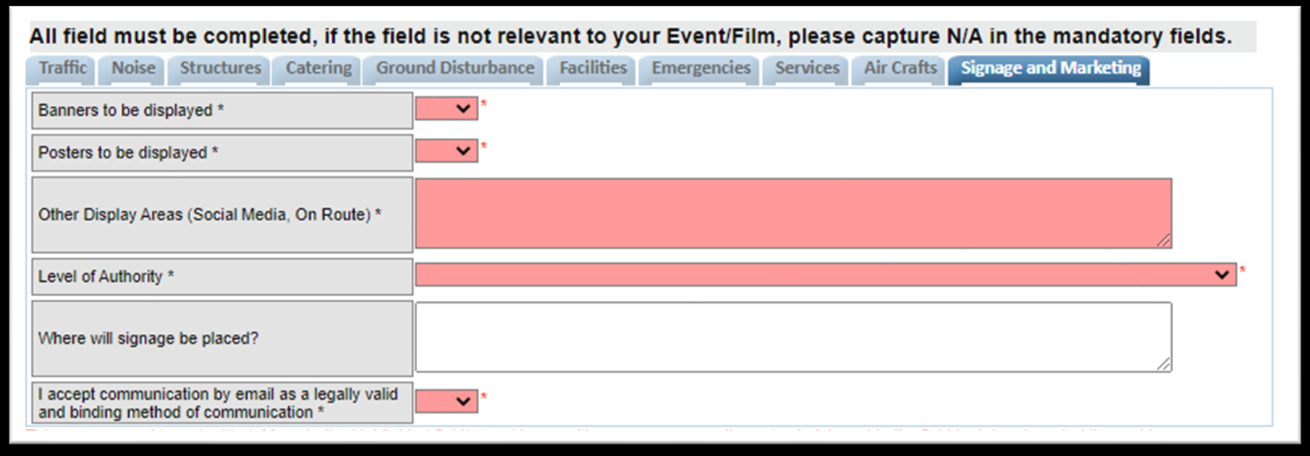
Step 23. Confirm the submitted application
You will be routed back to the Event Management landing page.
Highlight the Partner Name, then highlight the application you have just completed.
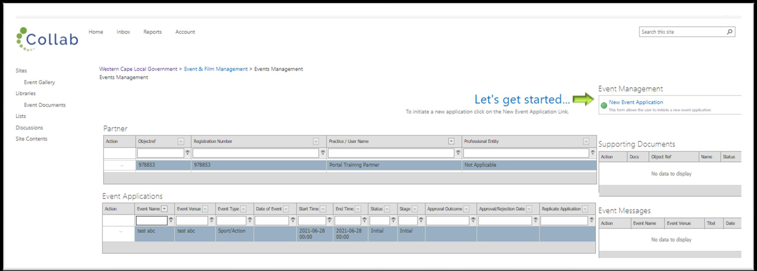
Step 24. Locate outstanding supporting documents
Highlight the application you are working on, then highlight the outstanding supporting document you want to upload.
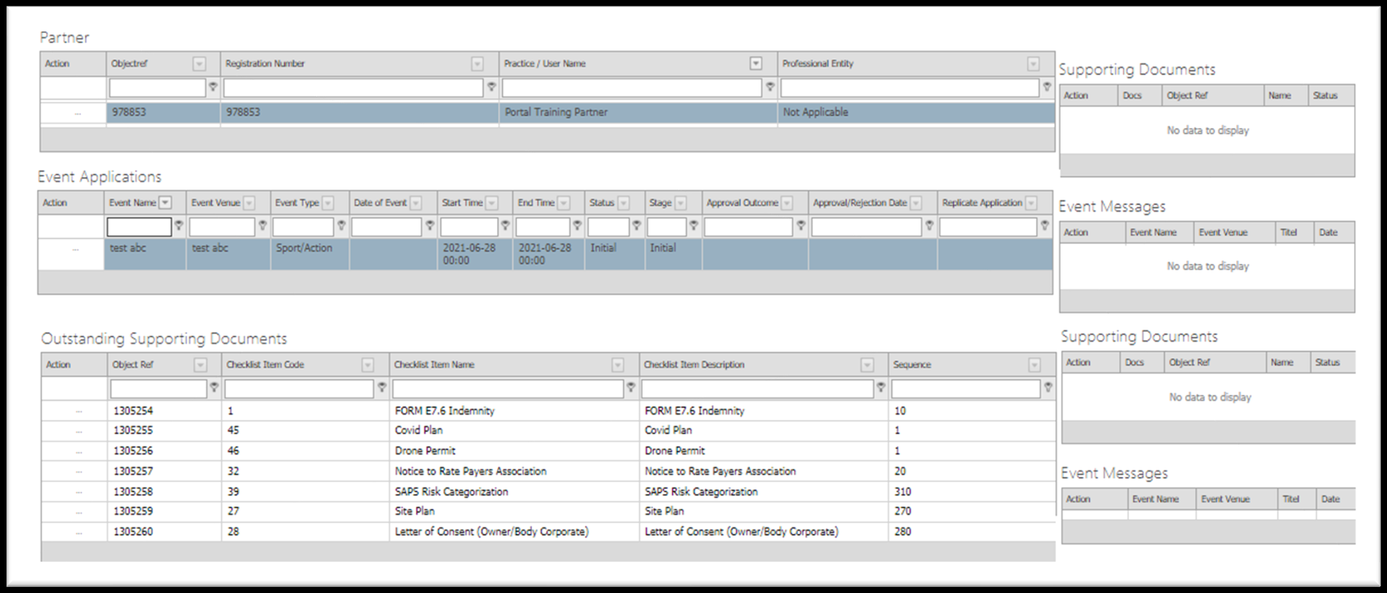
Step 25. Start the document upload
With the outstanding supporting document highlighted, click the action button, then select Add Document from the dropdown list.
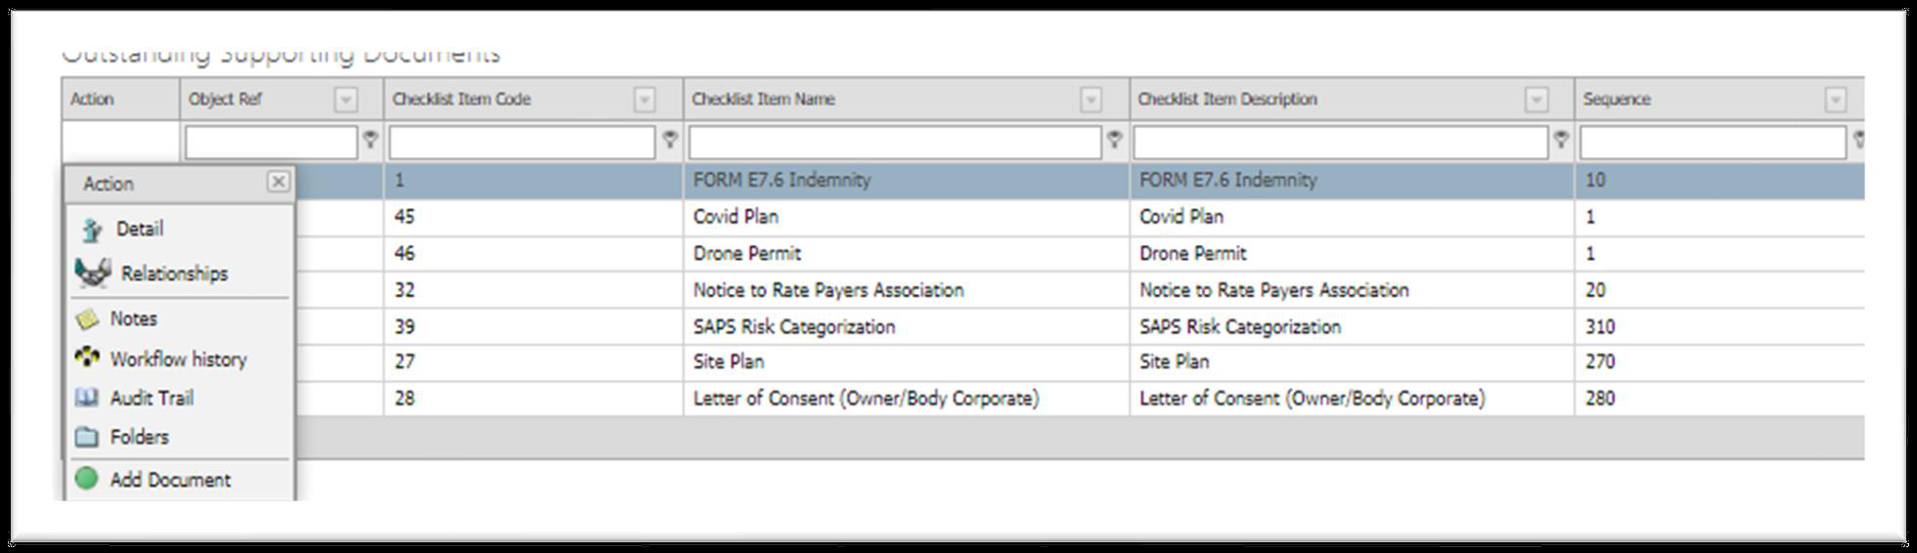
Step 26. Choose the file
The New Supporting Document task will open. Click Choose File to browse your computer.
Locate your document, highlight it and select Open.
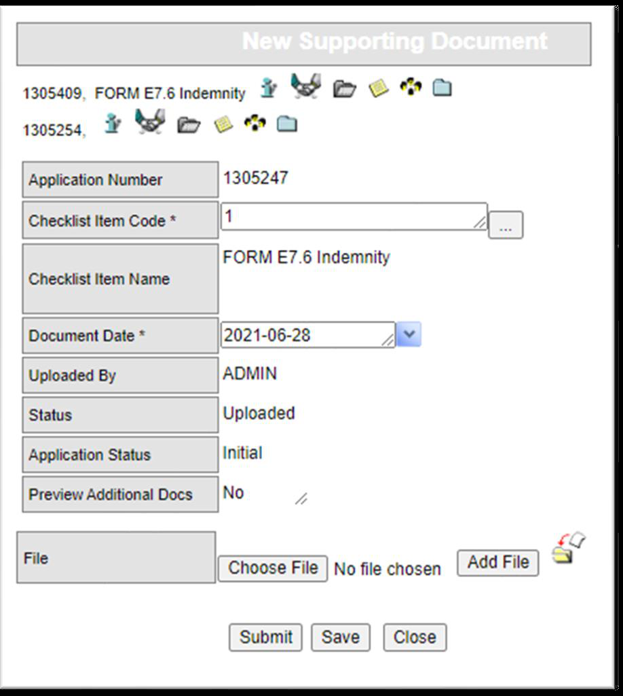
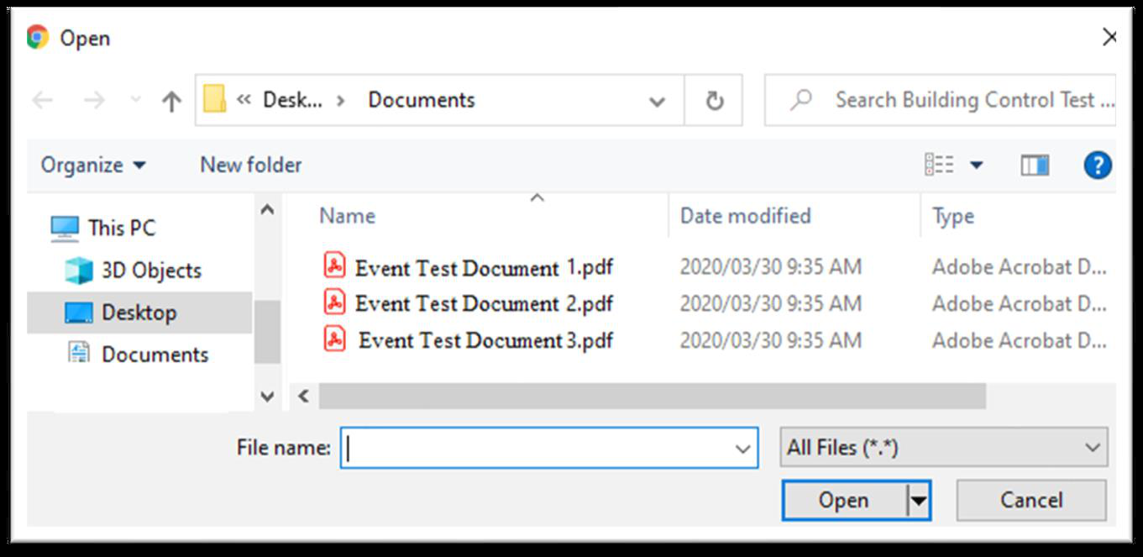
Step 27. Submit the document
The name of the selected document will appear next to Choose File — click Submit.
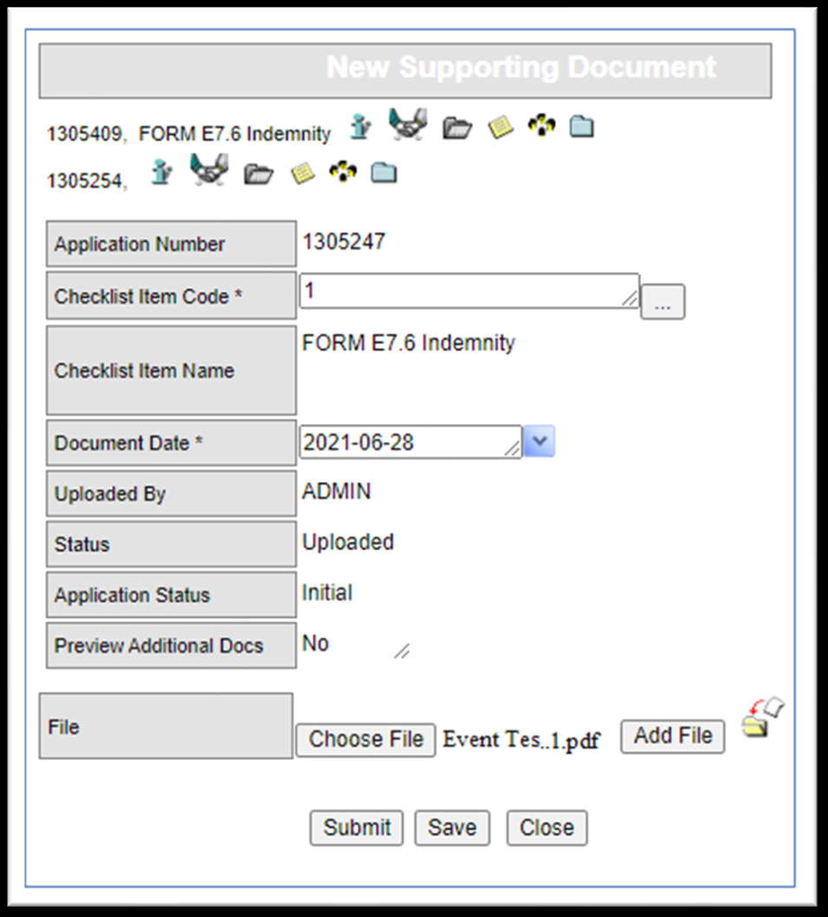
Step 28. Confirm the upload
The document moves from Outstanding Supporting Documents to the Supporting Documents web part.
Repeat this process to upload all remaining outstanding supporting documents.
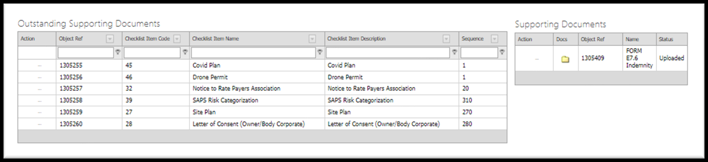
Step 29. Additional documents for specific municipalities
For TWK Municipality, you will also need to upload a Covid Plan as an additional supporting document.
Click the action button on the relevant application, select Additional Supporting Document, choose Covid Plan, select the file from your computer and click Submit.
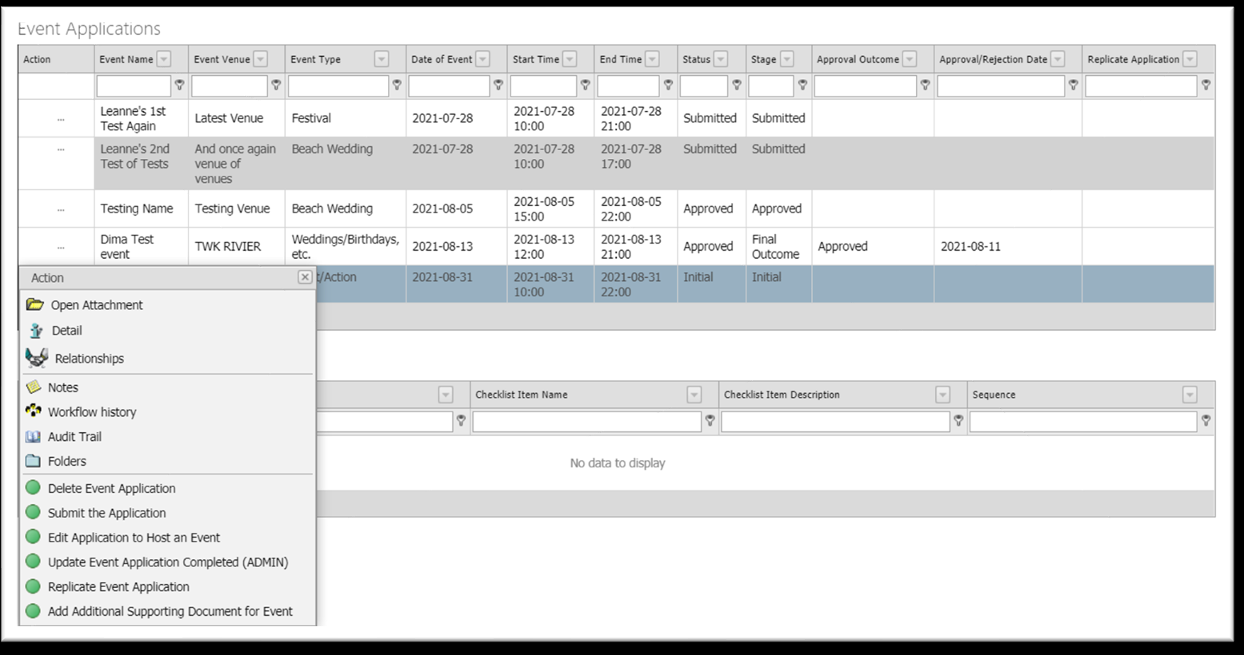
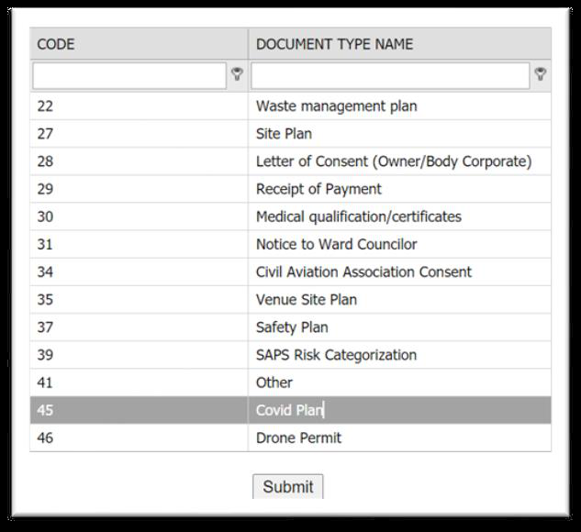
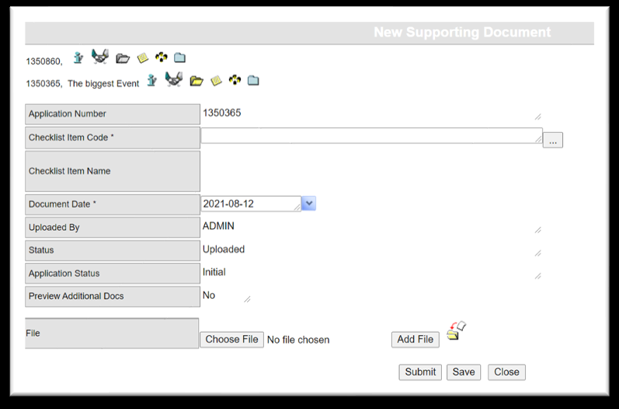
Step 30. All documents uploaded
Once all supporting documents have been uploaded, the Outstanding Supporting Documents web part will be empty and the Supporting Documents web part will display every uploaded document.
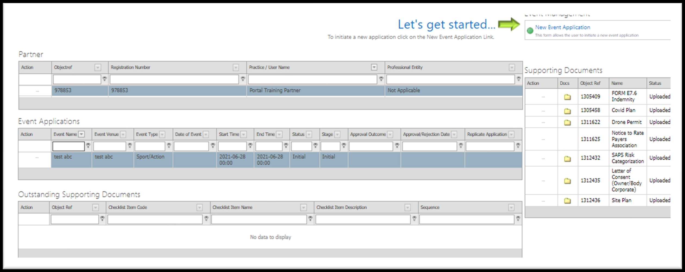
Step 31. Submit the application to the Municipality
Click the action button on the application and select Submit the Application to send it to the Municipality.
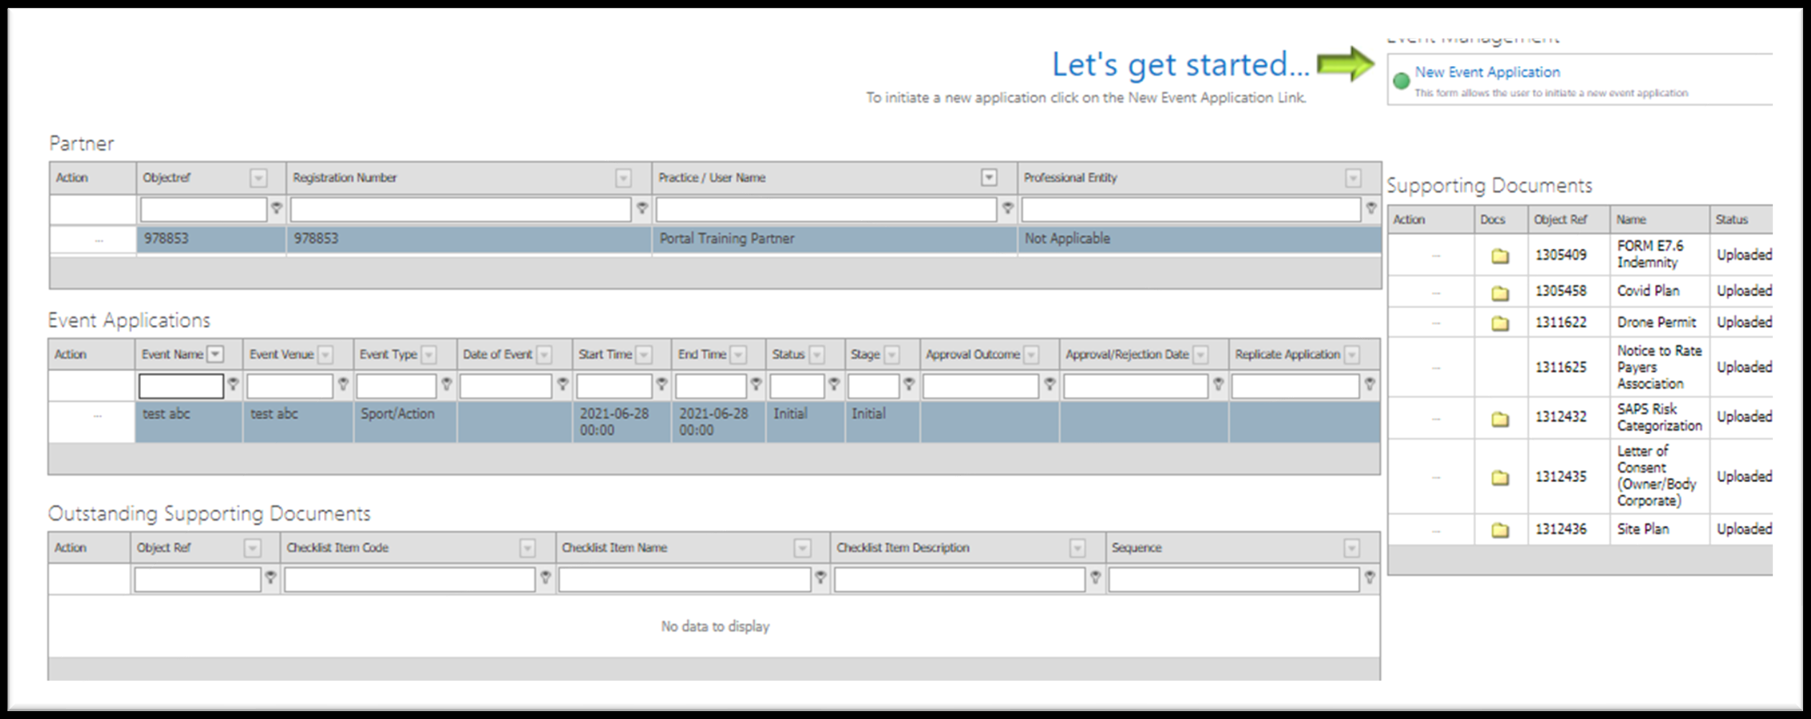
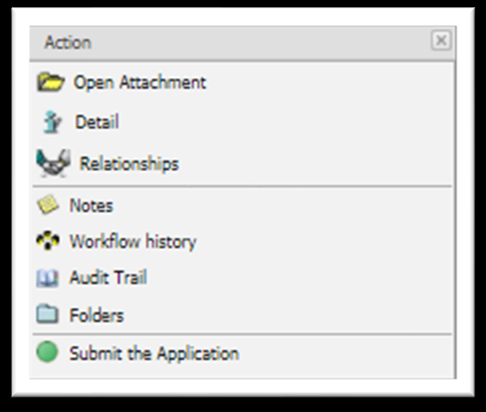
Step 32. Confirm submission
The next task opens — click Submit to update the application stage.
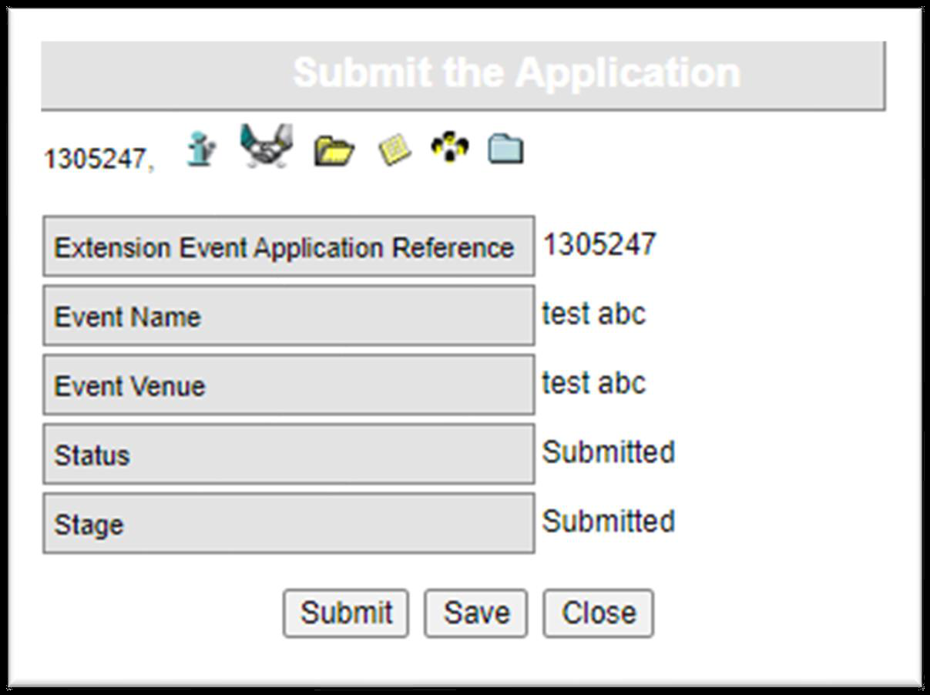
Step 33. Application submitted
The Stage column in the Event Applications web part updates to Submitted, confirming the application has been sent to the Municipality.
